AL-FARABI KAZAKH NATIONAL UNIVERSITY
Higher School of Medicine
Department of Fundamental Medicine

Final exam program of
“Morphology and physiology of human body”
(8 credits)

Topics for the final exam

- Muscular system 1: The Functions of Muscles, Muscle Attachments .Functional Groups of Muscles, Innervation and Blood Supply,Muscle Names and Learning Strategy
- Muscular system 2: Behavior of whole Muscle
- Human tissue 1: Microscopic Anatomy of Skeletal Muscle II
- Muscular system 3: Muscle Metabolism
- Muscular system 4: Muscles of the Anterior Abdominal Wall; Muscles of the Pelvic Floor.
- Human tissue 2: Nerve tissue
- Muscular system 5: Muscles of the Back. Muscles of Respiration
- Muscular system 6: Muscles of the head and neck
- Biophysics 1: The Nerve-Muscle Relationship. Behavior of Skeletal Muscle Fibers.
- Muscular system 7: Muscles Acting on the Shoulder and Arm; Muscles Acting on the Forearm, the Wrist and Hand.
- Muscular system 8: Muscles Acting on the Hip and Femur,Muscles Acting on the Knee and Leg
- Biophysics 2: The Nerve-Muscle Relationship. Behavior of Skeletal Muscle Fibers
- Muscular system 9: Muscles Acting on the Foot, Intrinsic Muscles of the Foot
- Blood 1: Introduction,Blood Types. Erythrocytes.
- Human tissue 3: Blood. Erythrocytes, leukocytes, blood platelets
- Blood 2: Leukocytes
- Blood 3: Platelets and Hemostasis, The Control of Bleeding
- Human tissue 4: Hemopoiesis
- Heart 1: Cardiac and Smooth Muscle
- Heart 2: Overview of the Cardiovascular System. Gross Anatomy of the heart.
- Heart 3: Cardiac Muscle and the Cardiac Conduction System
- Human tissue 5: Cardiovascular system. Heart. Layers of the Heart Wall.
- Heart 4: Electrical and Contractile Activity of the Heart
- Heart 5: Cardiac Output
- Human tissue 6: Cardiovascular system.Cardiovascular system. General description of vessels. Arteries and veins. Microcirculation stream. Arterioles. Capillaries. Venules.
- Blood vessels and circulation 1: General Anatomy of the Blood Vessels. Capillary Exchange.
- Blood vessels and circulation 2: Venous Return and Circulatory Shock
- Biophysics 3 Blood Flow, Heart Sounds,and the Cardiac Cycle
- Blood vessels and circulation 3: Special Circulatory Routes
- Blood vessels and circulation 4: Anatomy of the Pulmonary Circuit, Systemic Vessels of the Axial Region
- Biophysics 4: Blood Pressure, Resistance, and Flow
- Blood vessels and circulation 5: Anatomy of the Systemic Vessels of the Appendicular Region
- Human tissue 7: Respiratory system. Nasal cavity, trachea, bronchi, bronchioles, alveolar ducts.
- The Respiratory System 1: Anatomy of the Respiratory System
- The Respiratory System 2: Pulmonary Ventilation
- The Respiratory System 3: Gas Exchange and Transport
- The Respiratory System 4: Respiratory Disorders
- Human tissue 8: Human tissue 8.Histology of urinary system
- The urinary System 1: Functions of the Urinary System. Anatomy of the Kidney
- The urinary System 2: Urine Formation I: Glomerular Filtration
- The urinary System 3: Urine Formation II:Tubular Reabsorption and Secretion
- Human tissue 9: Histology of urinary system
- The urinary System 4: Urine Formation III: Water Conservation
- The urinary System 5: Urine and Renal Function Tests. Urine Storage and Elimination

Learning outcomes
Students on the final written and test exam must demonstrate in their responses the ability to:
- describe and identify the structural and organizational structure of internal organs, localize and describe, correctly using the appropriate terminology, on models, drugs and medical imaging materials, the typical structure of internal organs and systems of human organs (musculoskeletal system and skin, respiratory, circulatory systems) in the normal way, taking into account age, gender and individual characteristics;
- understand the functional organization of the human body at the cellular, systemic and organ level, the physiological processes of excitable tissues;
- recognize and identify micro-products; describe, correctly using the appropriate terminology, the microscopic structure of human organs, taking into account age, gender and individual characteristics;
- describe, using appropriate terminology, the stages of human development and explain the main processes and mechanisms of normal morphogenesis;
- explain the relationship of structure and function at the level of tissue, organs and organ systems, and the main physiological mechanisms for maintaining homeostasis, vital activity of the body and their features, taking into account age, gender and individual differences;\
- integrate knowledge about the structure of the musculoskeletal system, skin, respiratory and circulatory systems at the systemic, organ and tissue levels and their phylogenetic development to understand anatomical and physiological features in different periods of normal development;

A rough typology of tasks for the exam

To pass the exam in writing

№ | Lesson topics | Exam question
1 | Мышечная система:  - The Functions of Muscles, Muscle Attachments  Functional Groups of Muscles, Innervation and Blood Supply,Muscle Names and Learning Strategy  - Behavior of whole Muscle  - Microscopic Anatomy of Skeletal Muscle II  - Muscle Metabolism  - Muscles of the Anterior Abdominal Wall; Muscles of the Pelvic Floor;  - Nerve tissue  - Muscles of the Back. Muscles of Respiration  - Muscles of the head and neck  - The Nerve-Muscle Relationship. Behavior of Skeletal Muscle Fibers  - Muscles Acting on the Shoulder and Arm;  Muscles Acting on the Forearm, the Wrist and Hand  - Muscles Acting on the Hip and Femur,Muscles Acting on the Knee and Leg  - Muscles Acting on the Foot, Intrinsic Muscles of the Foot | describe the various functions of muscular tissue; relate muscle fascicles to the shapes and relative strengths of muscles; name the types of muscle-bone attachments and explain the shortcoming of calling their attachments origins and insertions; distinguish between intrinsic and extrinsic muscles; describe the ways muscles work in groups to aid, oppose, and moderate each other’s actions; describe in general terms the nerve and blood supply to skeletal muscles; explain how the Latin names of muscles aid in visualizing and remembering explain describe the stages of a muscle twitch; explain how successive muscle twitches can add up to produce stronger muscle contractions; distinguish between isometric and isotonic contraction; distinguish between concentric and eccentric describe the structural components of a muscle fiber; relate the striations of a muscle fiber to the overlapping arrangement of its protein filaments; name the major proteins of a muscle fiber and state the function of each  Describe the structural differences between cardiac muscle and skeletal muscle  Identification of structural features of the smooth and striated muscular tissues under a microscope and photomicrographs:  Structural features of striated muscle fibres.  Structural features of сardiac muscle tissue.  Mechanism of contraction of striated muscular explain how skeletal muscle meets its energy demands during rest and exercise; discuss why extra oxygen is needed even after an exercise has ended ;explain the basis of muscle fatigue and soreness; discuss the factors that affect muscular strength; discuss the effects of resistance and endurance exercises on muscles;  distinguish between two physiological types of muscle fibers, and explain their functional  name and locate the muscles of the abdominal wall, back, and pelvic floor ; identify the skeletal attachments, action, and innervation of these muscles.  Identification of the structural components of neurocytes (neurofibres, basophilic substance), myelinated and unmyelinated nerve fibres under a microscope and photomicrographs. Classification and structural features of neurocytes. Classification of the glia cells. Functional significance of the glia cells. Structural features of the myelinated and unmyelinated nerve fibres.  name and locate the muscles of the back; identify the skeletal attachments, action, and innervation of these muscles. name and locate the muscles of respiration and explain how they affect airflow and abdominal pressure; identify the skeletal attachments, action, and innervation of these muscles;  describe the physiological properties that all muscle types have in common; name and locate the muscles that produce facial expressions; name and locate the muscles used for chewing and swallowing; name and locate the neck muscles that move the head;identify the attachments, action, and innervation of these muscles.explain how the Latin names of muscles aid in visualizing and remembering explain what a motor unit is and how it relates to muscle contraction; describe the structure of the junction where a nerve fiber meets a muscle fiber; explain why a cell has an electrical charge difference across its plasma membrane and, in general terms, how this relates to muscle contraction; explain how a nerve fiber stimulates a skeletal muscle fiber  explain how stimulation of a muscle fiber activates its contractile mechanism; explain the mechanism of muscle contraction; explain how a muscle fiber relaxes; explain why the force of a muscle contraction depends on the muscle’s length prior to name and locate the muscles that act on the pectoral girdle, shoulder, elbow, wrist, and hand ;relate the actions of these muscles to the joint movements ;  name and locate the muscles that act on the elbow, wrist, and hand ; relate the actions of these muscles to the joint movements ; name and locate the muscles that act on the hip, knee joints; relate the actions of these muscles to the joint movements; describe the skeletal attachments, action, and innervation of these muscles;  explain what a motor unit is and how it relates to muscle contraction; describe the structure of the junction where a nerve fiber meets a muscle fiber; explain why a cell has an electrical charge difference across its plasma membrane and, in general terms, how this relates to muscle contraction; explain how a nerve fiber stimulates a skeletal muscle fiber  explain how stimulation of a muscle fiber activates its contractile mechanism; explain the mechanism of muscle contraction; explain how a muscle fiber relaxes; explain why the force of a muscle contraction depends on the muscle’s length prior to stimulation  name and locate the muscles that act on the ankle, and toe joints; relate the actions of these muscles to the joint movements; describe the skeletal attachments, action, and innervation of these muscles; describe the structural differences between smooth muscle and skeletal muscle  describe the functions and major components of the circulatory system;
2 | Circulatory System: Blood  - introduction,Blood Types. Erythrocytes  - Leukocytes  - Platelets and Hemostasis, The Control of Bleeding  - Hemopoiesis  - erythrocytes, leukocytes, blood platelets | describe the components and physical properties of blood; describe the composition of blood plasma; explain the significance of blood viscosity and osmolarity; describe in general terms how blood is produced; explain what determines a person’s ABO and Rh blood types and how this relates to transfusion compatibility; list some blood groups other than ABO and Rh and explain how they may be useful; describe the effects of a blood type incompatibility between mother and fetus  Describe the structure and function of erythrocytes (RBCs); describe the structure and function of hemoglobin; state and define some clinical measurements of RBC and hemoglobin quantities; describe the life history of erythrocytes; name and describe the types, causes, and effects of RBC excesses and deficiencies  discuss the structure of erythrocytes (RBCs); describe the structure of hemoglobin; discuss the structure of leukocytes;Structure of blood platelets. Identification of erythrocytes, thrombocytes and different types of leukocytes in blood smears under microscope and photomicrographs  explain the function of leukocytes in general and the individual role of each leukocyte type; describe the appearance and relative abundance of each type of leukocyte; describe the formation and life history of leukocytes; discuss the types, causes, and effects of leukocyte excesses and deficiencies  describe the body’s mechanisms for controlling bleeding; list the functions of platelets; describe two reaction pathways that produce blood clots ;explain what happens to blood clots when they are no longer needed; explain what keeps blood from clotting in the absence of injury;describe some disorders of blood clotting  describe the prenatal and postnatal hemopoiesis, stages of prenatal hemopoiesis. Erythropoiesis.Granulopoiesis.Monocytopoiesis. Lymphopoiesis. Platelet formation
3 | Circulatory System: Heart  - Cardiac and Smooth Muscle  - Overview of the Cardiovascular System.  Gross Anatomy of the heart  - Cardiac Muscle and the Cardiac Conduction System  - Cardiovascular system. Heart. Layers of the Heart Wall.  - Electrical and Contractile Activity of the Heart  - Cardiac Output | Describe the structural and physiological differences between cardiac muscle and skeletal muscle; explain why these differences are important to cardiac function; describe the structural and physiological differences between smooth muscle and skeletal muscle; relate the unique properties of smooth muscle to its locations and functions  describe some disorders of blood clotting define and distinguish between the pulmonary circuit and systemic circuit ; describe the general location, size, and shape of the heart; describe the pericardial sac that encloses the heart.  describe the three layers of the heart wall; identify the four chambers of the heart; identify the surface features of the sac heart and correlate them with its internal four-chambered anatomy; identify the four valves of the heart; trace the flow of blood through the four chambers and valves of the heart and adjacent blood vessels; describe the arteries that nourish the myocardium and the veins that drain it  describe the unique metabolic characteristics of cardiac muscle; explain the functional significance of the intercellular junctions between cardiac muscle cells; describe the heart’s pacemaker and internal electrical conduction system; describe the nerve supply to  the heart and explain its role  Structural features of the heart. Cardiac conduction system.  describe explain why the SA node fires spontaneously and rhythmically describe the unusual action potentials of cardiac muscle and relate them to the contractile behavior of the heart; interpret a normal electrocardiogram  define cardiac output and explain its importance; identify the factors that govern cardiac output; discuss some of the nervous and chemical factors that alter heart rate, stroke volume, and cardiac output;  explain how the right and left ventricles achieve balanced output; describe some effects of exercise on cardiac output
4 | Circulatory System: Vessels  - General Anatomy of the Blood Vessels  Capillary Exchange  - Cardiovascular system. General description of vessels. Arteries and veins. Microcirculation stream. Arterioles. Capillaries. Venules.  - Venous Return and Circulatory Shock  - Blood Flow, Heart Sounds,and the Cardiac Cycle  - Special Circulatory Routes  - Anatomy of the Pulmonary Circuit, Systemic Vessels of the Axial Region  - Blood Pressure, Resistance, and Flow  Anatomy of the Systemic Vessels of the Appendicular Region | describe the types of arteries, capillaries, and veins, microscopic and ultramicroscopic structural features of arteries and veins, structural features of blood capillaries, structure of microcirculation vessels.  trace the general route usually taken by the blood from the heart and back again; describe some variations on this route  describe how materials get from the blood into the surrounding tissues; describe and calculate the forces that enable capillaries to give off and reabsorb fluid; describe the causes and effects of edema.  explain how the brain maintains stable perfusion; discuss the causes and effects of strokes and transient ischemic attacks; explain the mechanisms that increase muscular perfusion during exercise; contrast the blood pressure of the pulmonary circuit with that of the systemic circuit, and explain why the difference is important in pulmonary function  trace the general route usually taken by the blood from the heart and back again; describe some variations on this route  explain how blood in the veins is returned to the heart; discuss the importance of physical activity in venous return; discuss several causes of circulatory shock; name and describe the stages of shock  explain why blood pressure is expressed in millimeters of mercury ; describe how changes in blood pressure operate the heart valves; explain what causes the sounds of the heartbeat, describe in detail one complete cycle of heart contraction and relaxation; relate the events of the cardiac cycle to the volume of blood entering and leaving the heart  explain how the brain maintains stable perfusion; discuss the causes and effects of strokes and transient ischemic attacks; explain the mechanisms that increase muscular perfusion during exercise; and contrast the blood pressure of the pulmonary circuit with that of the systemic circuit, and explain why the difference is important in pulmonary function.  identify the principal systemic arteries and veins of the axial region; trace the flow of blood from the heart to any major organ of the axial region and back to the heart. identify the principal systemic arteries and veins of the limbs; trace the flow of blood from the heart to any region of the upper or lower limb and back to the heart; trace the route of blood through the pulmonary circuit.  explain the relationship between blood pressure, resistance, and flow; describe how blood pressure is expressed and how pulse pressure and mean arterial pressure are calculated; describe three factors that determine resistance to blood flow; explain how vessel diameter influences blood pressure and flow; explain describe some local, neural, and hormonal influences on vessel diameter;  identify the principal systemic arteries and veins of the limbs; trace the flow of blood from the heart to any region of the upper or lower limb and back to the heart; trace the route of blood through the pulmonary circuit.
5 | The Respiratory System:  - nasal cavity, trachea, bronchi,bronchioles, alveolar ducts  - Anatomy of the Respiratory System  - Pulmonary Ventilation  - Gas Exchange and Transport  - Respiratory Disorders | Describe the basic components of the conducting and respiratory portions of the system ( nasal cavity, trachea, bronchi,bronchioles, alveolar ducts) structural elements the blood-air barier identification of structural components of the nasal cavity, trachea, bronchi, bronchioles under microscope and on the photomicrographs  state the functions of the respiratory system; name and describe the organs of this system; trace the flow of air from the nose to the pulmonary alveoli; relate the function of any portion of the; respiratory tract to its gross and microscopic anatomy.  name the muscles of respiration and describe their roles in breathing ; describe the brainstem centers that control breathing and the inputs they receive from other levels of the nervous system ; explain how pressure gradients account for the flow of air into and out of the lungs, and how those gradients are produced; identify the sources of resistance to airflow and discuss their relevance to respiration  define partial pressure and discuss its relationship to a gas mixture such as air; contrast the composition of inspired and alveolar air; discuss how partial pressure affects gas transport by the blood;  describe the mechanisms of transporting O2 and CO2; describe the factors that govern gas exchange in the lungs and systemic capillaries;  explain how gas exchange is adjusted to the metabolic needs of different tissues; discuss the effect of blood gases and pH on the respiratory rhythmexplain the significance of anatomical dead space to alveolar ventilation; define the clinical measurements of pulmonary volume and capacity; define terms for various deviations from the normal pattern of breathing  describe the forms and effects of oxygen deficiency and oxygen excess; describe the chronic obstructive pulmonary diseases and their consequences; explain how lung cancer begins, progresses, and exerts its lethal effects
6 | Urinary System:  - histology of urinary system  - Functions of the Urinary System  Anatomy of the Kidney  - Urine Formation I: Glomerular Filtration  - Urine Formation II:Tubular Reabsorption and Secretion  - Urine Formation III: Water Conservation  - Urine and Renal Function Tests  Urine Storage and Elimination | Development and structural features of the kidney. Renal tubules; reabsorption and secretion; renal endocrine apparatus; urinary tracts, identification of structural elements of the renal cortex, renal medulla, ureter, urinary bladder under the microscope and on the photomicrographs.  name and locate the organs of the urinary system; list several functions of the kidneys in addition to urine formation; describe the location and general appearance of the kidneys; identify the external and internal features of the kidney; trace the flow of blood through the kidney; trace the flow of fluid through the renal tubules; describe the nerve supply to the kidney.  describe the process by which the kidney filters the blood plasma, including the relevant cellular structure of the glomerulus; Explain the forces that promote and oppose filtration, and calculate the filtration pressure if given the magnitude of these forces; describe how the nervous system, hormones, and the nephron itself regulate filtration  describe how the renal tubules reabsorb useful solutes from the glomerular filtrate and return them to the blood; describe how the tubules secrete solutes from the blood into the tubular fluid; describe how the nephron regulates water excretion. explain how the collecting duct and antidiuretic hormone regulate the volume and concentration of urine; explain how the kidney maintains an osmotic gradient in the renal medulla that enables the collecting duct to function.  identification of structural elements of the ureter, urinary bladder under the microscope and on the photomicrographs.  explain how the collecting duct and antidiuretic hormone regulate the volume and concentration of urine; explain how the kidney maintains an osmotic gradient in the renal medulla that enables the collecting duct to function; and describe the hormonal mechanism for adjusting the body’s rate of water loss to its state of hydration or dehydration

To pass the exam in the test form

https://forms.gle/urMX29GRhxFQhQLn9 - demo test in Google Forms

Which of the following arteries DO NOT arise from the ascending aorta?
- Brachiocehal trunk
- left brachiocephalic artery
- left common carotid artery
- left subclavian

Identify the muscle labeled #1
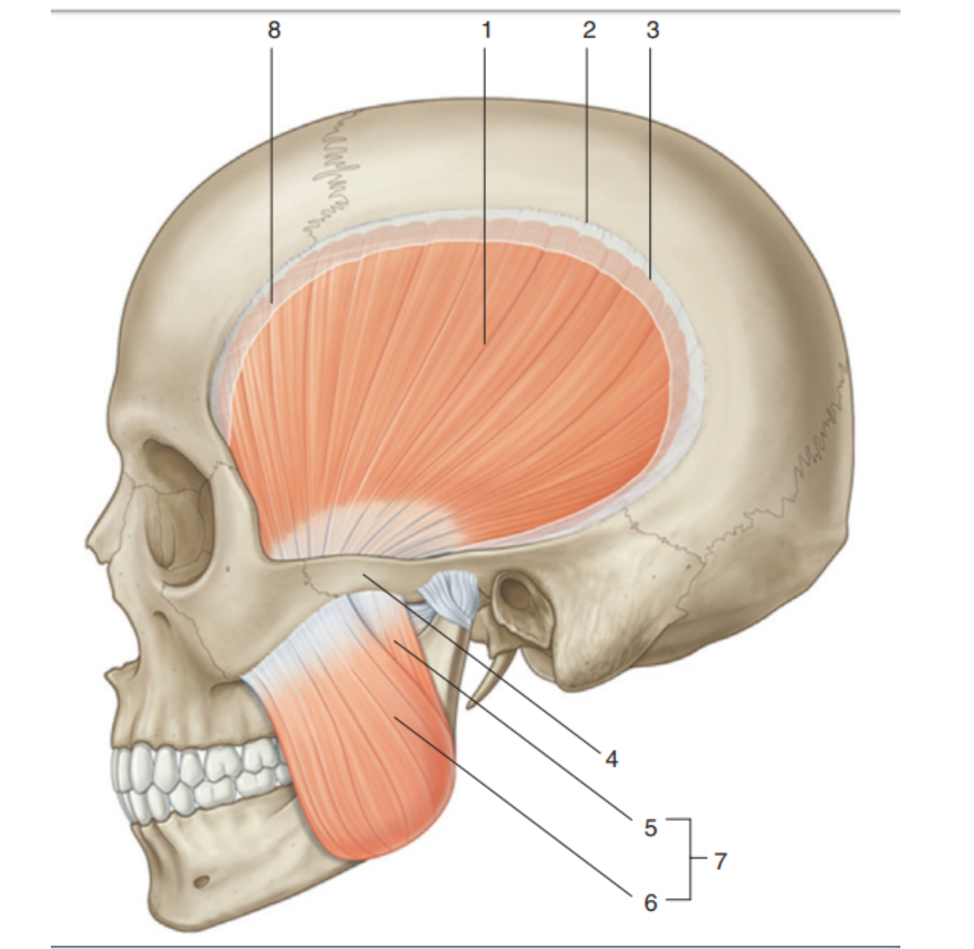

- Platysma
- Masseter
- M. procerus
- M. orbicularis oris
- M. temporalis+

Identify the vessel indicated by the # 20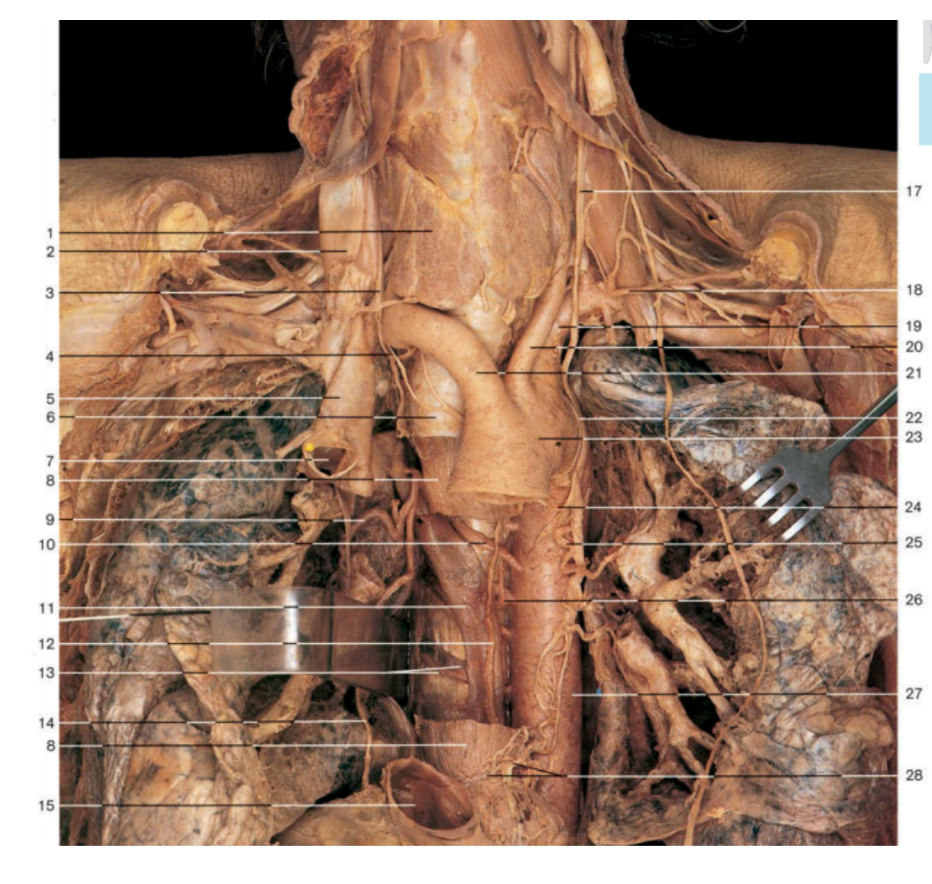
- Left common carotid artery+
- Brachiocephalic trunk
- The left subclavian artery
- aortic Arch
- Internal carotid artery

Follow this link and watch video. Write the name of muscle that highlighted in yellow color https://www.youtube.com/watch?v=MnWuRkrEoYA&list=PL8onlaAm1VBDSQqsWGDqbWYJzfk76PwGv&index=24

- Quadriceps femoris
- Soleus
- Gastrocnemius
- Biceps femoris
- Flexor digitorum longus

Watch the video and mark the name of the muscle marked in yellow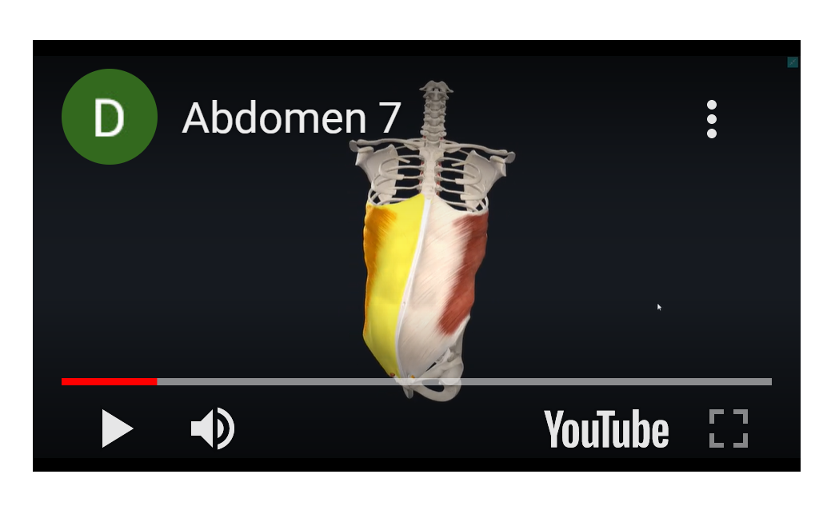

- +Oblique internus
- Rectus abdominis
- Inguinalis externus
- Oblique externus

Identify the formed element of blood, labeled #1: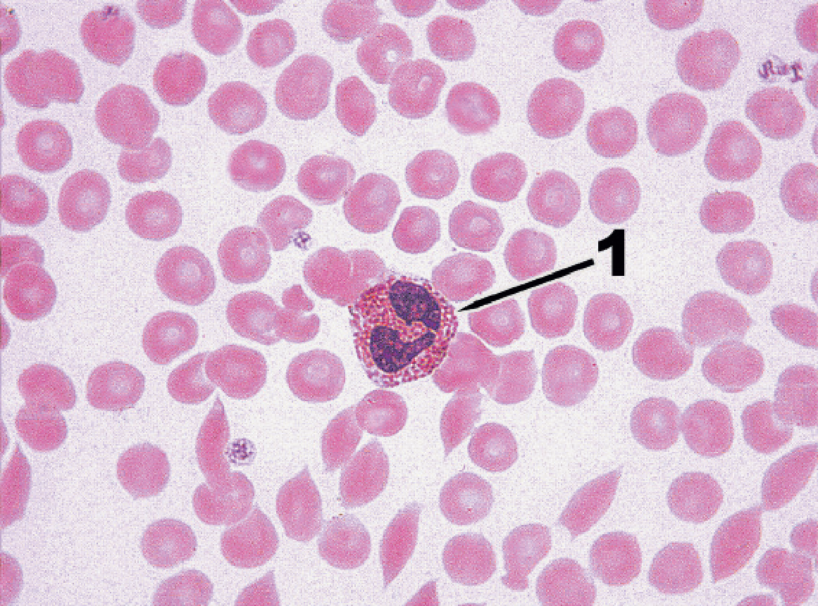

- Monocytes
- eosinophils
- neutrophils
- basophils
- lymphocytes

A standing man has a resting systolic blood pressure of 120 mmHg. At the beginning of the aorta. What will be the pressure in the arteries of his feet?

a. about 40 mmHg, since arterial blood pressure decreases with distance from the heart.
b. about 120 mm Hg, since arterial blood pressure does not drop noticeably until the blood enters the capillaries.
c. about 200 mm Hg, as the" head " of the fluid increases blood pressure in the legs+
d. about 80 mmHg, since blood pressure will drop in the absence of venous return when the "skeletal muscle pump" is not working

Example of an OSPE stations

5 station – the muscles of the lower limbs

Identify the muscles of the lower extremities listed below on the model. Fill in the empty fields in the table (number, name, function group, location group)

№ | Latin name | English name | Select a group by function  (flexor /extensor,  supinator /pronator,  abductor/adductor) | Select a group by location  (lateral /medial  / anterior /posterior)
 | M. flexor hallucis longus
 | M.gastrocnemius
 | M. gluteus medius
 | M. gracilis
 | M. vastus lateralis
 | M. flexor digitorum brevis
 | M. lumbrical
 | M. quadratus femoris

Station 8 - HISTOLOGY

Identify the tissue that you can now see under the magnification of the microscope. Then find a microphotograph of this tissue and describe it using the form below.

Description of microphotography

Name of the tissue under the microscope
Individual structural elements  (Research objects) | 1.  2.  3.  4.  5.
Structural features of this tissue
Function

The list of anatomical structures to be submitted to the exam (OSPE)

№ | Topic | Anatomical structures
 | Muscular System | Muscles of Head and Neck
1 |  | Frontalis
 |  | Orbicularis oculi
 |  | Occipitalis
 |  | Levator palpebrae superioris
 |  | Corrugator supercilii
 |  | Nasalis
 |  | Orbicularis oris
 |  | Levator labii superioris
 |  | Levator anguli oris
 |  | Zygomaticus major
 |  | Zygomaticus minor
 |  | Risorius
 |  | Depressor anguli oris
 |  | Depressor labii inferioris
 |  | Mentalis
 |  | Buccinator
 |  | Platysma
 |  | Genioglossus
 |  | Hyoglossus
 |  | Styloglossus
 |  | Palatoglossus
 |  | Temporalis
 |  | Masseter
 |  | Lateral pterygoid
 |  | Medial pterygoid
 |  | Digastric
 |  | Geniohyoid
 |  | Mylohyoid
 |  | Stylohyoid
 |  | Omohyoid
 |  | Sternohyoid
 |  | Thyrohyoid
 |  | Sternothyroid
 |  | Superior, middle, and inferior pharyngeal constrictors
 |  | Sternocleidomastoid
 |  | Anterior, middle, and posterior scalenes
 |  | Trapezius
 |  | Splenius capitis
 |  | Splenius cervicis
 |  | Semispinalis capitis
 |  | Semispinalis cervicis
 |  | Muscles of Trunk
 |  | Diaphragm
 |  | External intercostals
 |  | Internal intercostals
 |  | Innermost intercostals
 |  | External abdominal oblique
 |  | Internal abdominal oblique
 |  | Transverse abdominal
 |  | Rectus abdominis
 |  | Erector spinae
 |  | Semispinalis thoracis
 |  | Quadratus lumborum
 |  | Multifidus
 |  | Ischiocavernosus
 |  | Bulbospongiosus
 |  | Deep transverse perineal
 |  | Compressor urethrae
 |  | External anal sphincter
 |  | Levator ani
 |  | Muscles Acting on the Upper Limb
 |  | Pectoralis minor
 |  | Serratus anterior
 |  | Trapezius
 |  | Levator scapulae
 |  | Rhomboid minor
 |  | Rhomboid major
 |  | Pectoralis major
 |  | Latissimus dorsi
 |  | Deltoid
 |  | Teres major
 |  | Coracobrachialis
 |  | Supraspinatus
 |  | Infraspinatus
 |  | Teres minor
 |  | Subscapularis
 |  | Brachialis
 |  | Biceps brachii
 |  | Triceps brachii
 |  | Brachioradialis
 |  | Anconeus
 |  | Pronator quadratus
 |  | Pronator teres
 |  | Supinator
 |  | Flexor carpi radialis
 |  | Flexor carpi ulnaris
 |  | Flexor digitorum superficialis
 |  | Palmaris longus
 |  | Flexor digitorum profundus
 |  | Flexor pollicis longus
 |  | Extensor carpi radialis longus
 |  | Extensor carpi radialis brevis
 |  | Extensor digitorum
 |  | Extensor digiti minimi
 |  | Extensor carpi ulnaris
 |  | Abductor pollicis longus
 |  | Extensor pollicis brevis
 |  | Extensor pollicis longus
 |  | Extensor indicis
 |  | Adductor pollicis
 |  | Abductor pollicis brevis
 |  | Flexor pollicis brevis
 |  | Opponens pollicis
 |  | Abductor digiti minimi
 |  | Flexor digiti minimi brevis
 |  | Opponens digiti minimi
 |  | Four dorsal interosseous
 |  | Three palmar interosseous muscles
 |  | Four lumbrical muscles
 |  | Muscles Acting on the Hip and Femur
 |  | Iliacus
 |  | Psoas major
 |  | Tensor fasciae latae
 |  | Gluteus maximus
 |  | Gluteus medius and gluteus minimus
 |  | Gemellus superior
 |  | Gemellus inferior
 |  | Obturator externus
 |  | Obturator internus
 |  | Piriformis
 |  | Quadratus femoris
 |  | Adductor brevis
 |  | Adductor longus
 |  | Adductor magnus
 |  | Gracilis
 |  | Pectineus
 |  | Muscles Acting on the Knee and Leg
 |  | Quadriceps femoris
 |  | Rectus femoris
 |  | Vastus lateralis
 |  | Vastus medialis
 |  | Vastus intermedius
 |  | Sartorius
 |  | Biceps femoris
 |  | Semitendinosus
 |  | Semimembranosus
 |  | Popliteus
 |  | Muscles Acting on the Foot
 |  | Fibularis (peroneus) tertius
 |  | Extensor digitorum longus
 |  | Extensor hallucis longus
 |  | Tibialis anterior
 |  | Gastrocnemius
 |  | Soleus
 |  | Flexor digitorum longus
 |  | Flexor hallucis longus
 |  | Tibialis posterior
 |  | Fibularis brevis
 |  | Fibularis longus
 |  | Extensor digitorum brevis
 |  | Flexor digitorum brevis
 |  | Abductor digiti minimi
 |  | Abductor hallucis
 |  | Quadratus plantae
 |  | Four lumbrical muscles
 |  | Flexor digiti minimi brevis
 |  | Flexor hallucis brevis
 |  | Adductor hallucis
 |  | dorsal interosseous muscles
 |  | plantar interosseous muscles
2. | Heart | pericardial cavity
 |  | parietal pericardium
 |  | base of heart
 |  | apex of heart
 |  | superior vena cava
 |  | inferior vena cava
 |  | aortic arch
 |  | pulmonary trunk
 |  | pulmonary arteries
 |  | aorta
 |  | visceral pericardium
 |  | endocardium
 |  | myocardium
 |  | right and left atria
 |  | pectinate muscles
 |  | auricle
 |  | right and left ventricles
 |  | interventricular septum
 |  | fibrous rings (anuli fibrosi)
 |  | coronary (atrioventricular) sulcus
 |  | anterior interventricular sulcus
 |  | posterior interventricular sulcus
 |  | left atrioventricular (AV) valve
 |  | right AV (tricuspid) valve
 |  | papillary muscles
 |  | aortic valve
 |  | pulmonary valve
 |  | tendinous cords (chordae tendineae)
 |  | left coronary artery
 |  | anterior interventricular branch
 |  | circumflex branch
 |  | left marginal branch
 |  | right coronary artery
 |  | right marginal branch
 |  | posterior interventricular branch
 |  | great cardiac vein
 |  | posterior interventricular (middle cardiac) vein,
 |  | left marginal vein
 |  | coronary sinus
3. | Blood Vessels | Arteries
 |  | Veins
 |  | Capillaries
 |  | tunica interna (tunica intima)
 |  | endothelium
 |  | tunica media
 |  | tunica externa (tunica adventitia)
 |  | Conducting (elastic or large) arteries
 |  | Distributing (muscular or medium) arteries
 |  | arterioles
 |  | Carotid sinuses
 |  | Muscular venules
 |  | Arteriovenous anastomosis
 |  | superior lobar artery
 |  | inferior lobar arteries
 |  | ascending aorta
 |  | aortic arch
 |  | brachiocephalic trunk
 |  | common carotid arteries
 |  | left subclavian
 |  | descending aorta
 |  | vertebral arteries
 |  | thyrocervical trunks
 |  | costocervical trunks
 |  | external carotid artery
 |  | superior thyroid artery
 |  | lingual artery
 |  | occipital artery
 |  | maxillary artery
 |  | superficial temporal artery
 |  | ophthalmic artery
 |  | anterior cerebral artery
 |  | middle cerebral artery
 |  | basilar artery
 |  | posterior cerebral arteries
 |  | anterior cerebral arteries
 |  | anterior communicating artery
 |  | posterior communicating arteries
 |  | dural venous sinuses
 |  | superior sagittal sinus
 |  | inferior sagittal sinus
 |  | transverse sinuses
 |  | cavernous sinuses
 |  | internal jugular vein
 |  | facial vein
 |  | external jugular vein
 |  | vertebral vein
 |  | aortic hiatus
 |  | Bronchial arteries
 |  | Esophageal arteries.
 |  | Mediastinal arteries
 |  | Posterior intercostal arteries
 |  | Subcostal arteries
 |  | Superior phrenic arteries
 |  | internal thoracic artery
 |  | pericardiophrenic artery
 |  | anterior intercostal arteries
 |  | thoracoacromial trunk
 |  | subscapular artery
 |  | subclavian vein
 |  | brachiocephalic vein
 |  | superior vena cava
 |  | azygos vein
 |  | ascending lumbar vein
 |  | hemiazygos vein
 |  | inferior phrenic arteries
 |  | superior suprarenal arteries
 |  | celiac trunk
 |  | superior mesenteric artery
 |  | renal arteries
 |  | ovarian arteries
 |  | testicular arteries
 |  | lumbar arteries
 |  | median sacral artery
 |  | common iliac arteries
 |  | common hepatic artery
 |  | gastroduodenal artery
 |  | hepatic artery proper
 |  | splenic artery
 |  | left gastro-omental artery
 |  | ileal arteries
 |  | ileocolic artery
 |  | middle colic artery
 |  | sigmoid arteries
 |  | superior rectal artery
 |  | vaginal artery
 |  | obturator artery
 |  | internal pudendal artery
 |  | superior vesical artery
 |  | uterine artery
 |  | iliolumbar artery
 |  | superior gluteal artery
 |  | inferior vena cava
 |  | common iliac veins
 |  | lumbar veins
 |  | ovarian veins
 |  | testicular veins
 |  | renal veins
 |  | suprarenal vein
 |  | hepatic veins
 |  | ascending lumbar veins
 |  | hepatic portal system
 |  | inferior mesenteric vein
 |  | splenic vein
 |  | hepatic portal vein
 |  | cystic vein
 |  | subclavian artery
 |  | axillary artery
 |  | circumflex humeral arteries
 |  | brachial artery
 |  | radial collateral artery
 |  | ulnar collateral artery
 |  | radial artery
 |  | ulnar artery
 |  | interosseous arteries
 |  | palmar arches
 |  | dorsal venous network
 |  | cephalic vein
 |  | basilic vein
 |  | median cubital vein
 |  | median antebrachial vein
 |  | venous palmar arches
 |  | radial veins
 |  | ulnar veins
 |  | brachial veins
 |  | axillary vein
 |  | subclavian vein
 |  | external iliac artery
 |  | femoral artery
 |  | deep femoral artery
 |  | circumflex femoral arteries
 |  | popliteal artery
 |  | anterior tibial artery
 |  | dorsal pedal artery
 |  | arcuate artery
 |  | posterior tibial artery
 |  | lateral plantar arteries
 |  | deep plantar arch
 |  | fibular artery
 |  | dorsal venous arch
 |  | saphenous vein
 |  | deep plantar venous arch
 |  | fibular veins
 |  | popliteal vein
 |  | femoral vein
 |  | common iliac vein
4. | Respiratory System | Respiratory System
 |  | Nasal cavity
 |  | Hard palate
 |  | Nostril
 |  | Pharynx
 |  | Larynx
 |  | Trachea
 |  | Pleural cavity
 |  | Pleura (cut)
 |  | Epiglottis
 |  | Posterior nasal aperture
 |  | Soft palate
 |  | Esophagus
 |  | Left lung
 |  | Left main bronchus
 |  | Lobar bronchus
 |  | segmental bronchus
 |  | Diaphragm
 |  | Alar nasal sulcus
 |  | Dorsum nasi
 |  | Nasofacial angle
 |  | Nasal septum
 |  | Nasal bone
 |  | Lateral cartilage
 |  | Minor alar cartilages
 |  | Major alar cartilages
 |  | Dense connective tissue
 |  | Septal nasal cartilage
 |  | nose
 |  | nasal fossae
 |  | nasal conchae
 |  | nasopharynx
 |  | laryngopharynx
 |  | oropharynx
 |  | Frontal sinus
 |  | Meatuses
 |  | Tongue
 |  | Vestibular fold
 |  | Vocal cord
 |  | Uvula
 |  | Medulla oblongata
 |  | Pons
 |  | Auditory tube
 |  | Cribriform plate
 |  | Vestibule
 |  | Guard hairs
 |  | Upper lip
 |  | Naris (nostril)
 |  | Perpendicular plate
 |  | Septal cartilage
Vomer
Palatine tonsil

 |  | Lingual tonsil
 |  | Sphenoid sinus
 |  | Hyoid bone
 |  | Thyrohyoid ligamen
 |  | Thyroid cartilag
 |  | Laryngeal prominence
 |  | Arytenoid cartilage
 |  | Cricoid cartilage
 |  | Cricotracheal ligament
 |  | Cuneiform cartilage
 |  | Corniculate cartilage
 |  | Fat pad
 |  | Tracheal cartilage
 |  | Glottis
 |  | Main bronchi
 |  | Tracheal mucosa
 |  | Lateral cricoarytenoid muscle
 |  | Base of tongue
 |  | Trachealis muscle
 |  | Hyaline cartilage ring
 |  | Mucosa
 |  | Mucous gland
 |  | Perichondrium
 |  | Chondrocytes
 |  | Goblet cell
 |  | Ciliated cell
 |  | Mucociliary escalator
 |  | Apex of lung
 |  | Superior lobar bronchus
 |  | Horizontal fissure
 |  | Middle lobar bronchus
 |  | Middle lobe
 |  | Inferior lobar bronchus
 |  | Oblique fissure
 |  | Inferior lobe
 |  | Base of lung
 |  | Mediastinal surfaces
 |  | Costal surface
 |  | Cardiac impression
 |  | Diaphragmatic surface
 |  | Visceral pleura
 |  | Parietal pleura
 |  | Pleural cavity
 |  | Alveoli
 |  | Bronchial smooth muscle
 |  | Branches of pulmonary artery
 |  | Bronchiole
 |  | Alveolar sac
 |  | Terminal bronchiol
 |  | Respiratory bronchiole
 |  | Capillary networks around alveoli
 |  | Great alveolar cell
 |  | Alveolar macrophage
 |  | Respiratory membrane
 |  | Capillary endothelial cell
 |  | Squamous alveolar cell
 |  | Shared basement membrane
 |  | Pontine respiratory group (PRG)
 |  | Dorsal respiratory group (DRG)
 |  | Ventral respiratory group (VRG)
5. | Urinary System | kidneys
 |  | ureters
 |  | urinary bladder
 |  | urethra
 |  | hilum
 |  | renal fascia
 |  | perirenal fat capsule
 |  | fibrous capsule
 |  | renal sinus
 |  | renal cortex
 |  | renal medulla
 |  | renal columns
 |  | renal pyramids
 |  | renal papilla
 |  | minor calyx
 |  | major calyx
 |  | renal pelvis
 |  | renal artery
 |  | segmental arteries
 |  | interlobar arteries
 |  | arcuate arteries
 |  | cortical radiate arteries
 |  | afferent arterioles
 |  | nephron
 |  | glomerulus
 |  | efferent arteriole
 |  | peritubular capillaries
 |  | cortical radiate veins
 |  | arcuate veins
 |  | interlobar veins
 |  | renal vein
 |  | vasa recta
 |  | renal corpuscle
 |  | glomerular capsule
 |  | podocytes
 |  | capsular space
 |  | renal tubule
 |  | proximal convoluted tubule
 |  | nephron loop
 |  | descending limb
 |  | distal convoluted tubule
 |  | collecting duct
 |  | papillary duct
 |  | juxtamedullary nephrons
 |  | cortical nephron
 |  | renal plexus
 |  | juxtaglomerular apparatus
 |  | granular cells
 |  | mesangia cells
 |  | macula densa
 |  | principal cells
 |  | Intercalated cells
 |  | detrusor
 |  | external urethral orifice
 |  | urethral glands
 |  | internal urethral sphincter.

List of histological preparations for the exam

1.Striated skeletal muscular tissue of tongue
2.Myocardium
3. Neurofibrils in multipolar neurons of the anterior horns of the spinal cord.
4. Nissl bodies in the cytoplasm of motor neurons of the spinal cord
5. Myelinated nerve fibres
6. Nonmyelinated nerve fibres
7. Human blood smear. Erythrocytes
8. Human blood smear. Segmented neuthrophils.Thrombocytes
9. Human blood smear. Stab neuthrophils.Thrombocytes
10. Human blood smear. Eosinophil.
11. Human blood smear. Basophil.
12. Human blood smear. Monocyte
13. Human blood smear. Lymphocyte
14. Vessels of microcirculatory bloodstream. Venule
15. Muscular artery
16 .Muscular vein
17. Elastic artery
18.Trachea
19. Lung.Large bronchus
20.Lung. Medium bronchus
21. Lung. Small bronchus
22. Lung. Terminal bronchiole. Acinus
23. Kidney. Cortex
24.Kidney. Medulla
25. Kidney. Renal corpuscle. Proximal and distal convoluted tubules
26. Kidney. Renal corpuscle. Macula densa
27. Ureter
28. Urinary bladder

Response quality scale (written / oral response)

Mark | Criteria | Scale, points
Excellent | 1. all key aspects are included and presented logically;  2. high accuracy (relevance, without redundancy) and constant attention to the issue;  3. excellent integration of theoretical questions;  3. providing relevant examples;  4. in-depth analysis and theoretical justification of the problem (if applicable), all key aspects identified and interpreted;  5. fluency in professional terminology | 90 - 100
Good | 1. all key aspects are included and presented logically;  2. constant focus on the issue with satisfactory accuracy, relevance, and / or some redundancy;  3. satisfactory integration of theoretical questions;  3. the lack of examples;  4. satisfactory analysis and theoretical justification of the problem (if applicable), most of the key aspects identified and interpreted;  5. correct use of professional terminology | 75 - 89
Satisfactory | 1. most of the key aspects are included;  2. satisfactory focus on the question - some errors and / or noticeable redundancy;  3. theoretical problems presented without noticeable integration;  3. Providing failed examples or no examples;  4. some analysis and theoretical justification of this problem (if applicable), most of the key aspects are defined and interpreted;  5. correct use of professional terminology | 50 - 70
Unsatisfactory (FX) | 1. most of the key aspects are omitted;  2. lack of attention to the issue-irrelevant and significant redundancy;  3. some theoretical problems presented without integration and understanding;  3. missing or outdated examples;  4. some analysis and theoretical justification of this problem (if applicable), most of the key aspects are omitted;  5. problems in using professional terminology | 25 - 49
Unsatisfactory (F) | 1. most or all of the key aspects are omitted;  2. no focus on the question, not much related to the issue of information;  3. significant gaps in theoretical questions, or their superficial consideration;  3. the lack of examples or irrelevant examples;  4. there is no analysis and no theoretical justification for the given problem (if applicable), most of the key aspects are omitted;  5. problems in using professional terminology | 0-24

Grading system

Rating by letter system | Digital equivalent of points | Percentage | Evaluation using the traditional system
А | 4,0 | 95-100 | Excellent
А- | 3,67 | 90-94
В+ | 3,33 | 85-89 | Good
В | 3,0 | 80-84
В- | 2,67 | 75-79
С+ | 2,33 | 70-74 | Satisfactory
С | 2,0 | 65-69
С- | 1,67 | 60-64
D+ | 1,33 | 55-59
D- | 1,0 | 50-54
FX | 0 | 25-49 | Unsatisfactory
F | 0 | 0-24
I  (Incomplete) | - | - | «Discipline is not completed»  (it is not taken into account when calculating the GPA)
P  (Pass) | - | - | «Pass»  (it is not taken into account when calculating the GPA)
NP  (No Рass) | - | - | «Not pass»  (it is not taken into account when calculating the GPA)
W  (Withdrawal) | - | - | «Withdrawal»  (it is not taken into account when calculating the GPA)
AW  (Academic Withdrawal) |  |  | Academic Withdrawal  (it is not taken into account when calculating the GPA)
AU  (Audit) | - | - | «Audit»  (it is not taken into account when calculating the GPA)
Cert. |  | 30-60  50-100 | Certified
Not cert. |  | 0-29  0-49 | Not certified
R (Retake) | - | - | Repeated study of the discipline

Bibliography

Fundamental resources:

1. 1. Scanlon, V. C. Instructor’s guide essentials of anatomy and physiology Philadelphia, 2003. на анг. яз.
2. Costanzo, Linda S. Physiology [Electronic resource] : textbook / Philadelphia, 2006, на анг. яз.
Additional resources:

3. Case FilesTM [Electronic resource] : Anatomy / E. C. Toy, L. M. Ross, L. J. Cleary [et al.]. - 2nd ed. - Electronic text data 5.05 Mb. - New York ; Chicago ; San Francisco : McGraw-Hill , 2008. - 372 p. - The Main Page Title. - ISBN 0-07-164313-3. - ISBN 0-07-148980-0 : 0.00
4. Wilson, Britt. USMLE Step 1 [Electronic resource] : Physiology: lecture notes / B. Wilson. - Electronic text data 10.4 Mb. - New York : Kaplan Medical, 2017. - 421 p. - The Main Page Title. - ISBN 978-1-5062-0876-3 : 0.00

Online resources:

- https://app.lecturio.com/#/
- https://3d4medical.com/
- https://www.youtube.com/channel/UCc_I2c2bUtO0p4DVeo6-Kxg
- https://sites.google.com/a/umich.edu/bluelink/curricula/anatomy-403?authuser=0
- https://histologyknmu.wixsite.com/info/gistologicheskie-sajty
- https://histologyknmu.wixsite.com/info/gistologicheskie-sajty
- http://www.histology-world.com/contents/contents.htm
- http://www.histologyguide.com/slidebox/02-epithelium.html
- https://histology.medicine.umich.edu/resources
- https://web.duke.edu/histology/
- http://virtualslides.med.umich.edu/Histology/view.apml?listview=1&

